I Miss My Friends at School
My friends and I are not going to school because we don’t want to get sick. It is safer for us to stay at home. I might not get to see my friends for a while. I will miss them. Even though I can’t play with some of my friends, I can still talk to them. I could call them on the phone, FaceTime with them, or use other apps to send messages to them. I can ask an adult to help me contact my friend.
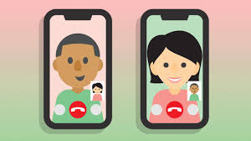
All of my friends have to stay at their homes. While we wait to see each other again, we can play with our toys and have fun at home. I can hang out with my family. I might play games, do puzzles, or watch movies. When I go outside, I might see some of the kids in my neighborhood. I can wave and say hi. I should not be too close to others, give high 5s, or give hugs. I could ride my bike or take a walk outside.
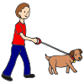

When it is safe for everyone to go back to school, I will be so happy to see my friends again and they will be happy to see me!

